Name- Dandupati Geethanjali
Dept-CSE
Batch start date-24-11-25
Batch end date-28-11-25
Project title -Disaster Relief Coordination App
Project link -https://my-site-g3l5ggit-geethanjalidandupa.wix-vibe.com
Screenshots
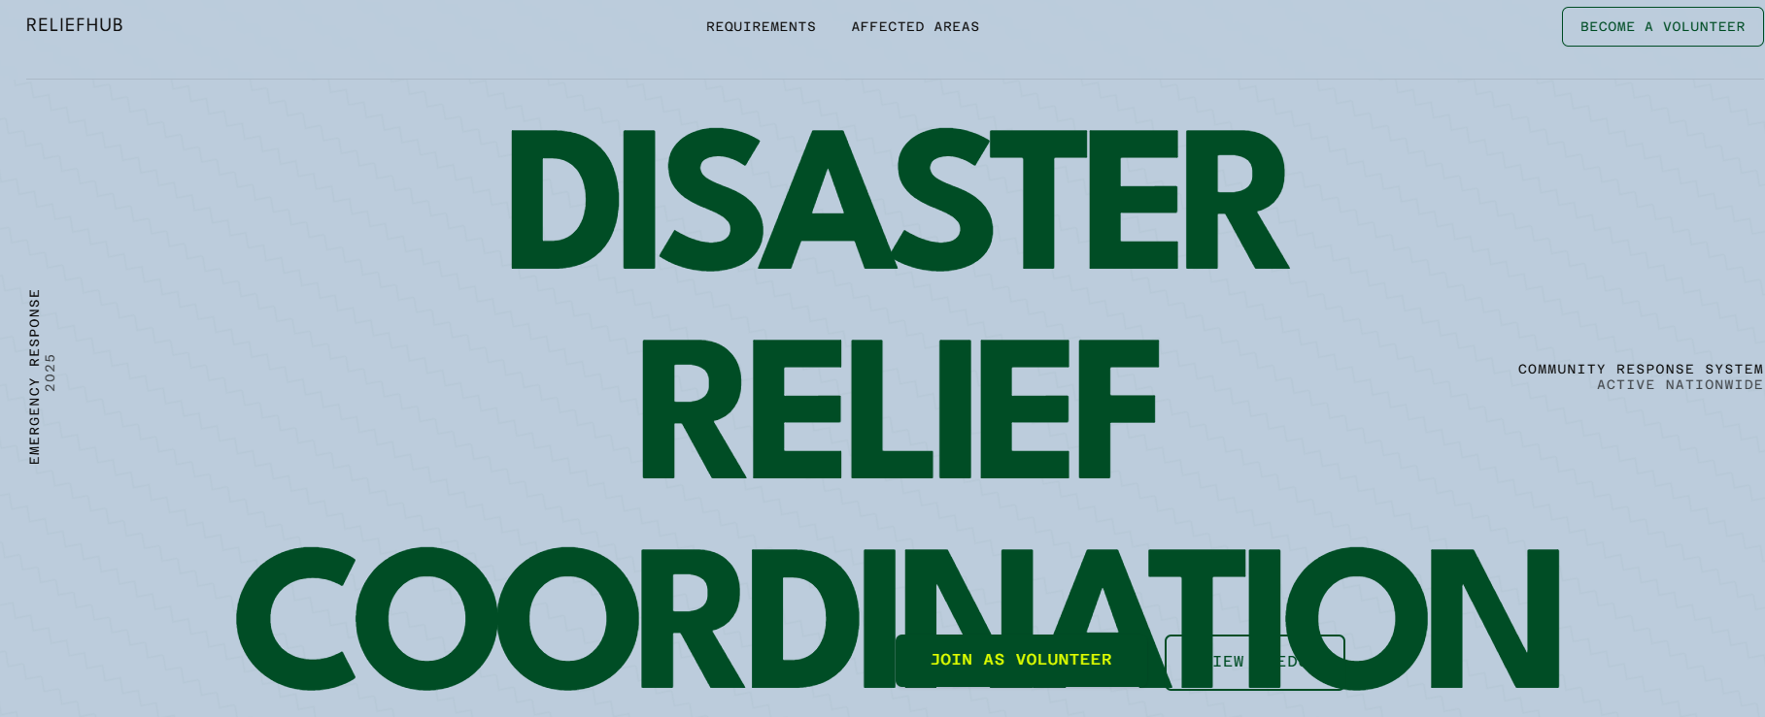
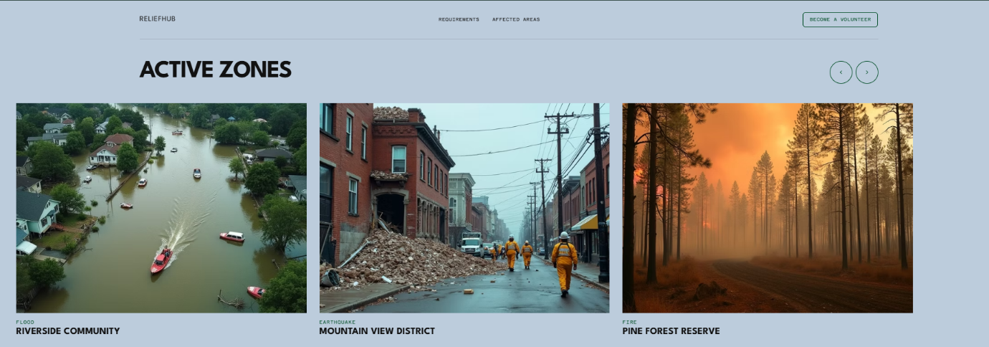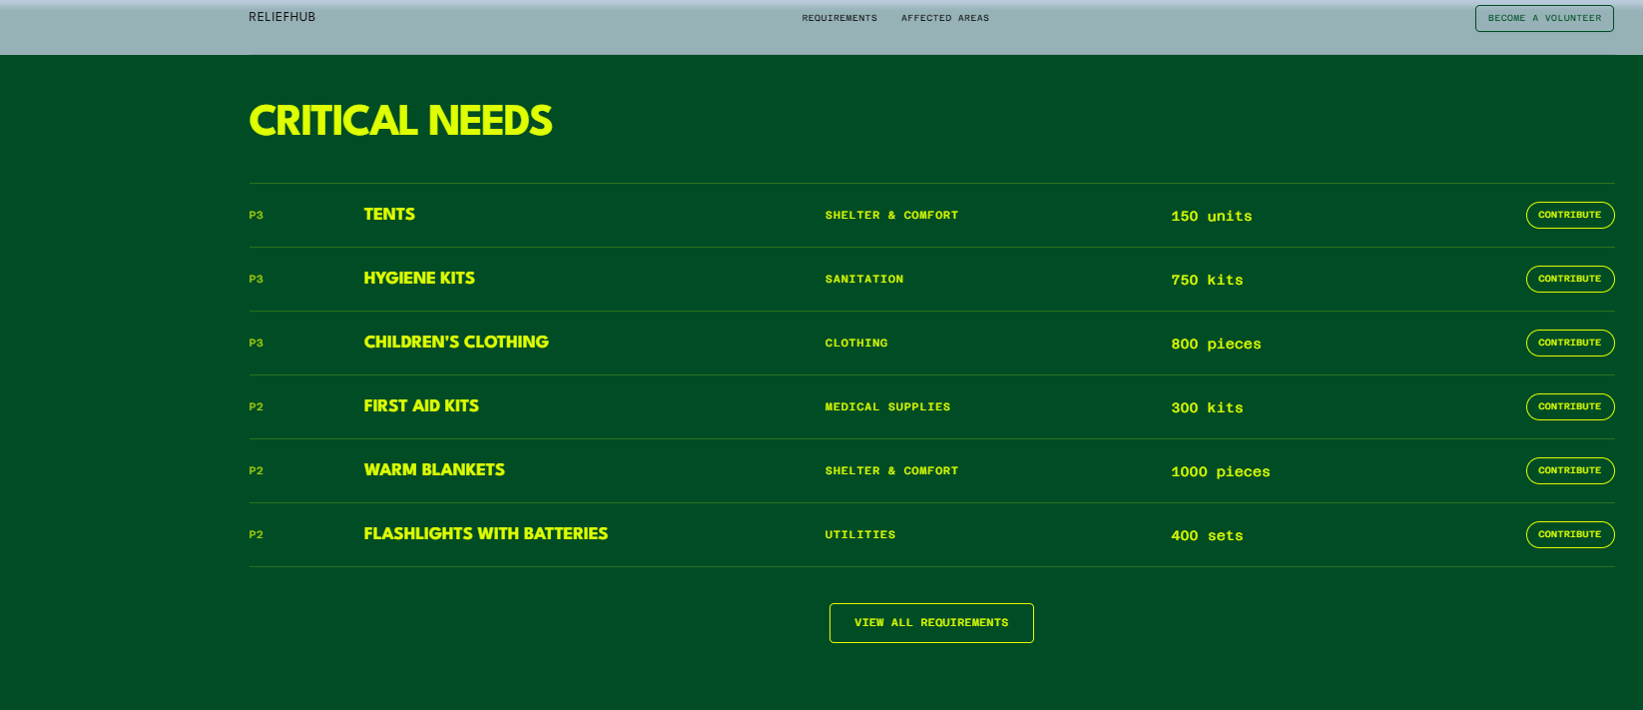

Description
The Disaster Relief Coordination App is a no-code, open-source platform designed to improve and accelerate community responses during natural disasters such as floods, earthquakes, landslides, and fires. Built using Airtable for backend management and Appsmith for the user-facing interface, the application centralizes information, streamlines communication, and ensures that timely assistance reaches the people who need it most.
The app begins with a simple and accessible volunteer registration system, where individuals can sign up by submitting their contact details, availability, and specific skills such as first aid, logistics, transport, or technical rescue. This data allows relief coordinators and NGOs to quickly identify the right volunteers and deploy them effectively during emergencies.
A second core component is the Requirements Board, where affected families, community leaders, or local NGOs can list essential needs such as food, clothing, medicines, hygiene kits, or shelter materials. Each request includes details like quantity, urgency level, and location. Volunteers and donors can instantly view these requirements, reducing duplication and ensuring that resources are delivered efficiently.
The app also features a live, interactive map that highlights disaster-affected zones, shelters, hospitals, and supply distribution points. This geolocation-supported visualization helps responders assess critical areas, optimize travel routes, and coordinate ground operations more effectively.
A notable element of the system is its AI-driven priority sorting, powered by Airtable’s automated formulas and Appsmith logic. This feature automatically ranks requests based on urgency, the number of people impacted, distance to available resources, and how long the need has been pending. As a result, the most critical cases always rise to the top, helping coordinators make faster, informed decisions.
Overall, the Disaster Relief Coordination App enhances transparency, reduces chaos, connects volunteers with real needs, and ensures quicker, more organized disaster response—ultimately saving time, resources, and lives.

Thank you IBM and magic bus India foundation

